**Automated**

**Test**

**Documentation**

# About automated test

## What knowledge need to learn

Python, Robot Framework, Xpath, Appium, Android SDK

## Automated test flow

1. You need to know which function can to do automated test
2. Write automated test cases with Excel
3. Deploy automated test environment
4. Write automated test cases with Robot Framework (use Ride, IEDA, Eclipse, pyCharm and so on)
5. Configure Jenkins to dispatch test case execution
6. View test report mail, analyze failure report, submit bugs or modify test cases

Change cases

Yes

No

Learn the knowledge for automated test

Manual testing

No

Yes

Deploy automated test environment

Execution test case and analysis report

Write test cases with Robt Framework

Analysis requirements and write test cases with Excel

Automated test?

Failure of test cases execution

Is bug?

JIRA

# How to deploy automated test environment?

## 2.1 what tools do we need?

Python 3 -- (servers)

Robot-framework --(servers)

Appium (>1.8.0) --(client)

Android SDK --(client)

## How to deploy client for windows system?

### 2.2.1 Download tools

Download Appium from <http://appium.io> and install.

Download Android SDK Tools from <https://developer.android.com> and install.

### 2.2.2 How to configure system variables for Android SDK?

1. Open Computer Properties - Advanced System Settings - Environment Variables.

2. Add the variable value in the user variable PATH

{your Android SDK install path} \ platform-tools

{your Android SDK install path} \ tools

then click OK.

A close up of a sign

Description generated with high confidence 3. Click Run 🡪 Enter CMD 🡪 Enter 🡪 Enter ADB --version 🡪 Enter. If there is print Android Debug Bridge version **, as shown in the figure below, it means that the configuration is successful. When you enter Android, start Android SDK Manager.

### 2.2.3 Update Android SDK Tools

#### 1. Click Run 🡪 Enter CMD 🡪 Enter 🡪 Enter android 🡪Enter, start Android SDK Manager.

#### 2. Choose that options as shown in the figure below, click Install packages. Android 7.1.1(API 25) is required.

### 2.2.4 How to start android simulator?

#### 1. Click Run 🡪 Enter CMD 🡪 Enter 🡪 Enter android AVD🡪Enter, start Android AVD Manager.

#### 2. Click Create, choose Device = Nexus 5, Target = Android 7.1.1, …, click OK to completed create.

#### 3. Choose the created android simulator, click Start.

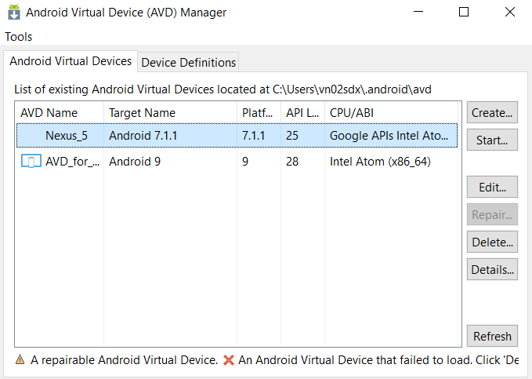

## How to deploy client for Mac system?

### 2.3.1 Download tools

Download Appium from <http://appium.io> and install.

Download Android SDK Tools from <https://developer.android.com> and install.

### 2.3.2 How to configure system variables for Android SDK?

1. Open the terminal and enter: ls -an

check that the ".bash_profile" file exists, skip step 2 if it exists

2.Enter: touch .bash_profile

3.Enter: open .bash_profile

4. Input configuration content:

export ANDROID_HOME=/Users/***/Library/Android/sdk

export PATH=$PATH:$ANDROID_HOME/tools

export PATH=$PATH:$ANDROID_HOME/platform-tools

5. Sava, enter source .bash_profile to make configuration effective.

6. Enter android, start Android SDK Manager.

### 2.3.3 Update Android SDK Tools

#### 1. Open the terminal and enter: android, start Android SDK Manager.

#### 2. See 2.2.3 Update Android SDK Tools

### 2.3.4 How to start android simulator?

#### 1. Open the terminal and enter: android AVD, start Android AVD Manager.

#### 2. See 2.2.4 How to start android simulator

## 2.4 How to deploy the servers?

### 2.4.1 Install Python (3+)

Download Python 3+ from <https://python.org> and install.

### 2.4.2 Install Robot Framework

Pip install robotframework

### 2.4.3 Configure Jenkins

Documentation: <https://jenkins.io>

# Write automated test case

## How to Write test cases

### About Robot Framework

<https://robotframework.org>

Standard libraries :

<http://robotframework.org/robotframework/#standard-libraries>

How to write good test cases using Robot Framework:

<https://github.com/robotframework/HowToWriteGoodTestCases/blob/master/HowToWriteGoodTestCases.rst>

### 3.1.2 The test cases list which need to do auto test for CPU project



### 3.1.3 where are the automated test cases

<https://gecgithub01.walmart.com/score-e2e-auto>

## How to start-up automated test cases

Pybot -i smoke TestCase ( execution smoke Tags' test cases in the folder TestCase )

CPU project file:

<https://gecgithub01.walmart.com/score-e2e-auto/AUTO_TEST/README.md>

## Start-up automated test case from Jenkins

<http://util.yuanhengtech.cn/jenkins/job/Score_Smoke_Test>

A screenshot of a cell phone

Description generated with very high confidence

# Concluding remark

Document continuous update …